FIELD JUNIOR SCHOOL

GOVERNORS INDUCTION

HANDBOOK

|  |
| --- |
|  |



# Introduction

This document explains the general operating procedures adopted by the Governing Body of Field Junior School and should be read in conjunction with the Department of Education [Governance Body Handbook](https://www.gov.uk/government/uploads/system/uploads/attachment_data/file/481147/Governance_handbook_November_2015.pdf) 2017 .

The purpose of this document is to assist new governors in their understanding of the Governing Body of Field Junior School. This document forms part of the induction process for new Governors, in addition to a comprehensive range of courses organised by Herts for Learning Governance Training team.

# The Role of a Governor

School governors are in place to ensure schools are well run. They are volunteers who help to decide on the direction, focus and ethos of the school. Governors represent school staff, parents, the local community and even the church organisation connected to the school. This means that school decisions are made by people with a wide range of experience and views.

Governors are part of the School Leadership Team

We believe:

Positive relationships between governors and other school leaders are based on:

* Open, honest dialogue.
* A clear understanding of the different roles and responsibilities.
* A shared commitment to securing the very best provision and outcomes for the pupils.

Governors need to know their School:

* Governors need a range of good quality, regular information from a variety of sources.
* They need to accurately understand the school’s strengths and areas for development.
* They must be well informed and knowledgeable about the school.
* Governors consistently ask for more information, explanation or clarification in order to make a strong contribution.

A school governing body has a strategic role in the development of the school but does not become involved in day-to-day management issues – that is the role of the Head Teacher.

You are there to:

* Provide a strategic view - help to set and maintain the broad framework within which the Head Teacher and the staff should run the school.
* Act as a critical friend - provide the Head Teacher with support and offer advice and information but also to provide some challenge. The governing body is there to monitor and evaluate the school’s effectiveness and governors should therefore be prepared to ask challenging questions.
* To ensure accountability - the Head Teacher and staff report to the governing body on the school’s performance. In turn the governing body is accountable to all stakeholders on the school’s overall performance.

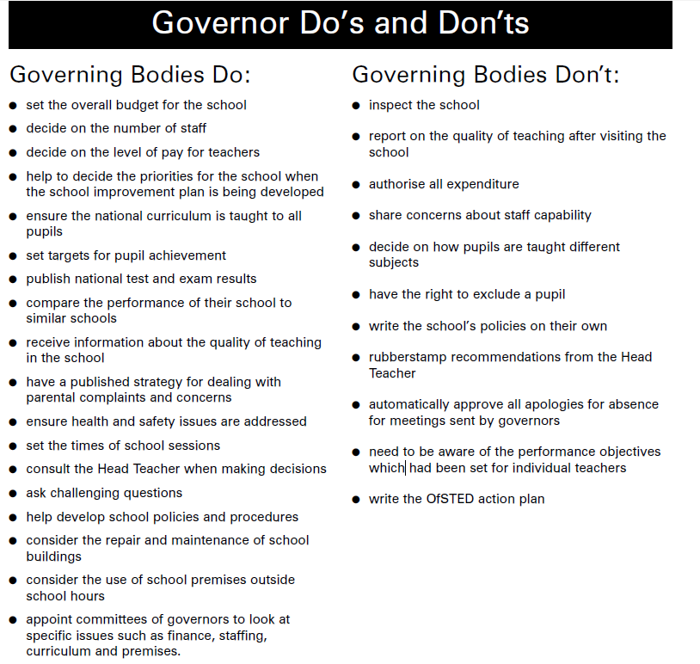

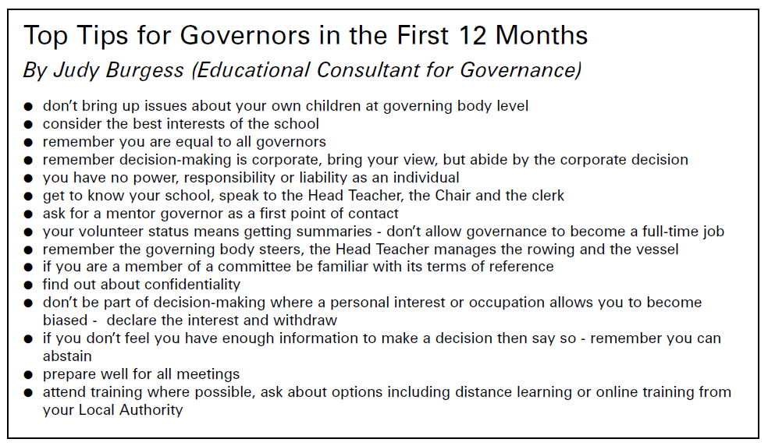

## Different types of governor:

Parent Governors - parents or carers elected by other parents or carers with children at the school or, on occasion, appointed by the governing body;

Staff Governors - the Head Teacher and staff members elected by teaching and support staff;

Co-opted Governors - individuals chosen by governors from the local community who represent community interests;

LA Governors - appointed by the Local Authority who take regard of the skills and experience which schools require and appoint candidates who support the schools’ ethos and mission;

Associate Members - a discretionary category appointed by the governing body from individuals who may be able to make specific contributions, but who is not a governor and has no vote at full governing body meetings but may have limited voting rights at committee level.

# Governance Structure

The Full Governing Body meets once a term and has established three committees with delegated responsibilities as defined in the committees Terms of Reference. These Committees meet once a term.

**Field Junior School Governing Body: Organisation**

Clerk to Governing Body

Chair of Governors

Vice-Chair of Governors

Chair & Members of Teaching and Learning Committee

(covers curriculum and data)

Chair and Members of Pay Committee meet once a year.

(Covers Headteacher’s pay and the pay and performance reviews of staff)

Chair and Members of Resources Committee

(Covers Building, Premises, Finance, Personnel and Pay Review) and Headteacher’s Performance Review panel)

# Induction of New Governors

**Aim:**

At Field Junior School, we give our new governors access to Herts for Learning Governor training to help them become more understanding of the work required as a school governor.

**Objectives:**

* To enable new and experienced governors to work together.
* To build and to develop their understanding of the governing body.

**Implementation:**

After a new governor accepts the governorship of the school they will be issued with a log in to Governor Hub in order to access all the documentation they need and will be asked to attend the Herts for Learning induction course for new governors.

Governance Pre-Appointment Declaration form

It is mandatory that all governors complete the Pre-appointment declaration form and DBS (Disclosure and Barring Service) application as soon as possible so that the appropriate safeguarding checks are carried out before any Governor duties commence.

Supply 2 References through the school office.

## Register of Pecuniary Interests

It is mandatory that if a governor has a financial interest in any matter under consideration, then that governor must withdraw from the meeting at which the issue is being discussed. ‘Having a pecuniary interest’ is a term with quite a wide remit. It includes people who own companies and people who are employed by them. It even extends to relatives, including spouses, who live with the governor and who themselves would have a pecuniary interest.

You must sign a declaration of interests on becoming a Governor, please obtain the form from the Clerk to the Governing Body.

(This is all set out in the DfE Governance Handbook).

At every meeting of the Full Governing Body, the issue will appear as an agenda item and governors will be reminded of their statutory obligation to declare an interest in any relevant item of interest and withdraw from the meetings as appropriate.

## Equality Duties

The governing body has responsibility for making sure that the school complies with the Equality duties set out in the Race Relations Act 1976 (as amended by the Race Relations Act 2000), the Disability Discrimination Act 1995 (as amended by the Disability Discrimination Act 2005) and the Sex Discrimination Act 1975 (as amended by the Equality Act 2006). The general duty on schools is to have due regard to the need to eliminate unlawful discrimination and to promote equality of opportunity in the area of race, disability and gender. Specific duties require schools to implement specific equality schemes in those areas.

# School Strategic Information Available

|  |  |  |
| --- | --- | --- |
| **School Strategic Information**  **and its significance** | **Timing** | **Source** |
| Analyse School Performance (ASP)data & Inspection Dashboard  Puts school in national rather than county context | Nov | OFSTED |
| Benchmarking data  Gives school comparative financial and resource information | June | Government Website |
| SATS Key Stage 2 | July | School |
| Current reports from Herts Improvement Partners (HIP) | Approx. Dec, April & July | Herts Improvement Partner |

# New Governors Induction Training – External Courses

The following Herts for Learning training courses are recommended as the minimum requirement for new Governors in their first year.

[www.hertsforlearning.co.uk](http://www.hertsforlearning.co.uk)

**IND01 - Induction for Governors -** ESSENTIAL FOR ALL GOVERNORS

An overview of the roles and principle areas of responsibility, including getting to know your school; governors meetings; sources of information and support; the paperwork; personnel and finance; together with an introduction to your LA.

**SC01 - Safeguarding Children – ESSENTIAL FOR ALL GOVERNORS**

This course is essential for all governors, and governors should be re-trained every 4 years.

Other training may be beneficial depending on the level of competence and the specific committees on which governors are on.

Appendix

## Glossary of terms

**Academies** - Publicly funded independent schools established under Section 482 of the Education Act 1996. Achievement now takes into account the standards of attainment reached by pupils and the progress they have made to reach those standards. Attainment: this is the standard of academic attainment, typically shown by test and examination results.

**Admission Authority –** This is the body responsible for setting the criteria, determining the admission number. In our case this is Hertfordshire County Council.

**AfL** - Assessment for Learning

**AIO** – Attendance Improvement Officer

**Appraisal** - A review of an employee’s performance.

**ARE** – Age related Expectations

**ASD** - Autistic Spectrum Disorder.

**ASP** Analyse School Performanceis a web-based system to disseminate school performance data to schools. Formally known as Raiseonline

**AWPU** - Age Weighted Pupil Unit – the sum of money allocated to the school for each pupil according to age. This is the basic funding for the school.

**Baseline Assessment** - Assessment of a pupil’s attainment when they join the school.

**Capital Expenditure** - Spending on projects, improvements and extensions to the school.

**Capital Funds** - cannot be spent on day-to-day maintenance work.

**CSD** Children’s Services Department

**CLA- Child Looked after (in care)**

**Clerk to the Governing Body** - A person appointed to carry out administrative duties on behalf of the Governing Body, such as preparing the agenda for and minuting termly Governor Meetings.

**Community School** - A term to describe an LEA maintained school.

**Core Curriculum** - English, Maths and Science

**CPD**- Continuing Professional Development

**DBS Checks - Disclosure and Barring Service.** Previously known as Criminal Records Bureau checks.

**DfE** Department for Education

**DTG** - Development & Training Governor

**EAL** - English as an additional language.

**EBD** Emotional and Behavioural Difficulties

**ECM** Every Child Matters

**EHC – Education Health & Care Plan** (formerly known as a Statement)- The procedure by which a child is formally assessed as having significant special education needs requiring more support than a school can provide from its normal resources.

**EOTAS** Education other than at school

**Exclusion** - The temporary or permanent banning of a pupil from the school.

**Early Years Foundation Stage (EYFS)** - formerly called Early Years, this covers children in the Nursery and Reception Classes.

**EXS**- Expected Standard at end of Key Stage

**GDS**- Greater depth Standard at end of Key Stage

**FGB –** Full Governing Body

**FSM** - Free School Meals.

**HfL**- Herts for learning (Local Authority)

**ICT** - Information and Communications Technology.

**INCO** – Inclusion Manager

**INSET** - In-service education and training for staff.

**Instrument of Government** - A legal document setting out the composition of the Governing Body.

**ISDR**- inspection data summary report

**Key Stage 1-4 - KS1** pupils aged 5-7 **KS2** pupils 7-11 **KS3** pupils aged 11-14 **KS4** pupils 14-16

**LA/LEA** - Local Education Authority – Hertfordshire County Council

**LSA** - Learning Support Assistant

**MSA** – Mid day Supervisory Assistant

**MPS** - Main Pay Spine, which structures incremental pay for teachers

**National Curriculum** - Established by the 1988 Education Act to ensure that pupils receive a broad and balanced education.

**NCSL** National College of School Leadership

**NGA** - National Governors’ Association.

**NOR** - Numbers on roll - The total number of pupils on the school’s register

**NPQH** National Professional Qualification for Headship - a qualification to prepare people for headship

**NQT** - Newly qualified teacher in his/her induction year, at the end of which s/he has to meet a range of standards in order to achieve QTS (Qualified Teacher Status).

**OFSTED** - Office for Standards in Education. The body that arranges and sets standards for school inspections.

**P levels** Pre-levels, used to assess pupils pre-national curriculum achievements.

**Performance Appraisal/Management** - A yearly review system for all staff.

**PLASC** - Pupil Level Annual School Census.

**PPA** - Planning, preparation and assessment – guaranteed non-contact time for teachers.

**PSHE** Personal, Social and Health Education

**PPG-Pupil Premium** - Extra sum of money from Government paid per pupil who has FSM (Free School Meals) or is a Looked After Child or a child of someone serving in the Armed Forces.

**PPM**- Pupil Progress Meetings

**Quorum** - The minimum number of members at a meeting before decisions can be made.

**QCA** Qualifications and Curriculum Authority

**QTS** Qualified Teacher Status.

**ASP** Analyse School Performanceis a web-based system to disseminate school performance data to schools.

**RE** Religious Education

**RSE- Relationships and Sex Education**

**SATs** - Standard Attainment Tests, taken at the end of each Key Stage.

**Scheme of Delegation** - Part of the Finance Committee’s Terms of Reference – to specify the responsibilities and limits of the Governing Body’s financial delegation to the Finance Committee.

**Self Evaluation Form (SEF)** – This was a non-statutory document, containing judgements about the school. The official SEF document was withdrawn in July 2011, though Ofsted still expect schools to carry out self-evaluation, so the document used for this is still sometimes referred to as the SEF.

**SEMH**- Social, emotional, mental health.

**SIP** School Development & Improvement Plan

**SEND** - Special Educational Needs and Disabilities – learning difficulties for which special educational provision has to be made. This may include children with physical disabilities or emotional and behavioural disorders.

**SENCo** - Specialist leader in SEN education

**SFVS** - Schools Financial Value Standard, auditing system completed annually (replaces FMSIS – Financial Management in Schools).

**SIMS** - School Information and Management System – a computer package to assist schools in managing information on pupils, staff and resources.

**SLD** Severe Learning Difficulties

**SLT** Senior Leadership Team

**SMSC** - Spiritual, moral, social and cultural development.

**SSE** School Self-evaluation

**Sports Premium** – Extra sum of money paid to schools by government to be utilised to promote sport and healthy lifestyles for children.

**Support Staff** - All employees at the school other than teachers.

**SWHP**- South West Herts Partnership

**TLRs** - Teaching and Learning Responsibilities that warrant salary enhancement

**UPS** - Upper Pay Spine.

**Virement** - The agreed transfer of money from one budget cost centre to another.

**WFR** - Workforce remodelling