*********Child Protection Policy for our children 2024***

At Pixmore School, all staff know that your health, safety and welfare and very important. We respect our children and help to protect your rights.

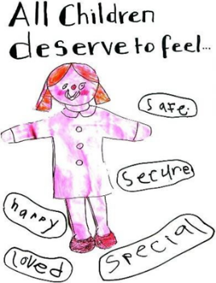We will always do our best to help you make good progress in your education, but also teach you how to recognise risks in different situations, and how to protect yourself and stay safe. ***We believe that there is nothing too small, or too awful, that you cannot speak to someone about it.***

***Safeguarding*** means that school staff will:

* Protect you from harm
* Make sure that nothing stops you from being healthy or developing properly
* Make sure you are looked after safely
* Do our best to make sure that you have the best life chances and can grow up to be happy and successful

***What happens when I have shared a worry with someone in school?***

* Very often, adults will be able to help you with your worries in school, and this is all that you will need to help you to feel safe and make you feel less worried
* Sometimes an adult in school will need to check things with Mrs Inman, Mrs Willans or Miss Pocock, and they will decide what needs to happen next to keep you safe.
* There are times when they may need to speak with other adults outside of school, such as social workers or the Police. There are lots of other agencies who are there to help children and their families when they need it.
* The adults in school will talk to you and explain all of this, and answer any questions you may have. They will reassure you that you have done nothing wrong, that it is not your fault, and that they want to keep you safe.

***How will we try to keep you safe and protect you from harm?***

* We try to provide a safe and secure environment for you to learn and make progress with your learning.
* We try to ensure that you remain safe at school, as well as at home and when you are away from home and online
* We think it is important that you know how to keep yourself safe, and to know where to go to get help when you are worried about something



***Need to talk?***

* ***If you need to talk – we will listen.*** You can talk to any adult in school who you feel comfortable talking to, and they will listen
* If you find it difficult to say what your worry is, write it down, or draw it, and give it to an adult
* Or you can call **Childline on 0800 1111** where someone is available to help you every day, including days when you are not in school.