Moss Bury Primary School and Nursery
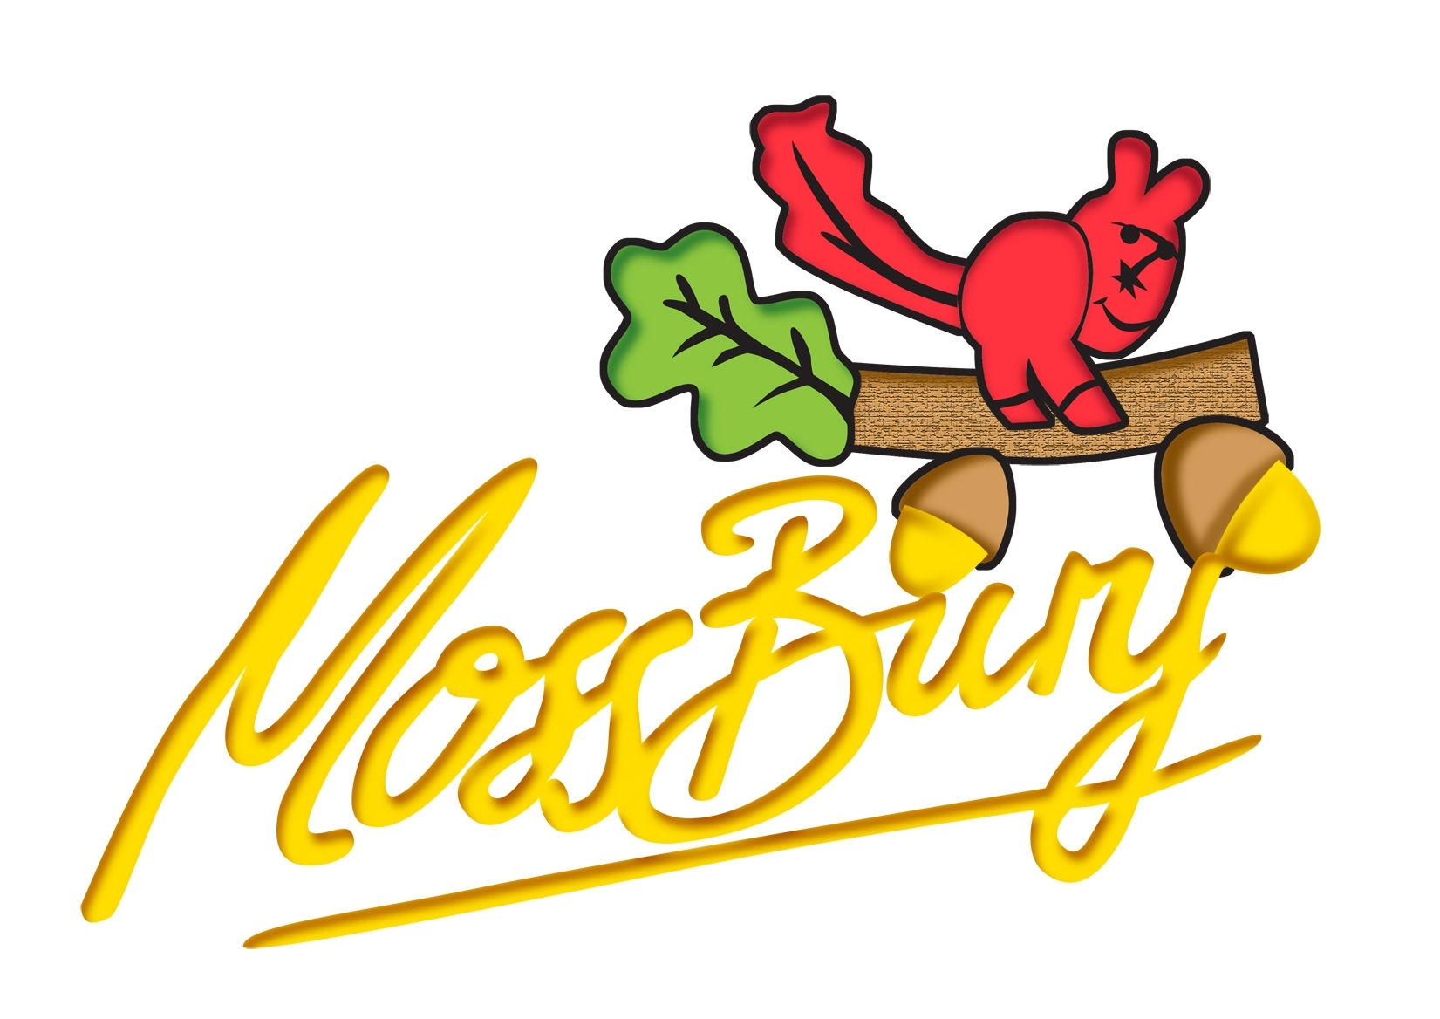
Webb Rise
Stevenage
Hertfordshire
SG1 5PA
Tel: 01438 222 300
Fax: 01438 222 301
e-Mail :admin@mossbury.herts.sch.uk

Person specification based upon Job Description for Class Teacher role

 | Essential | Desirable
Qualifications and Experience
Qualified Teacher Status (QTS) | Y
Evidence of Professional development | Y
Experience of working with children with a range of needs and abilities | Y
Evidence of good or outstanding teaching practise | Y
Experience of curriculum planning, assessing and recording | Y
Effective involvement with parents | Y
Knowledge and Understanding
Good knowledge of safeguarding and child protection procedures | Y
Knowledge of recent developments in education | Y
What constitutes quality and high standards in teaching and learning | Y
Strategies for engaging all learners | Y
Achieving high standards | Y
Commitment to school vision, policies and initiatives
Good working knowledge of health and safety requirements | Y
Skills and Abilities
Proven ability as a class teacher to secure progress at all levels | Y
Good behaviour management skills | Y
Good classroom practice | Y
Good organisational skills | Y
Ability to work within and contribute to team development | Y
To have a ‘can do’ attitude | Y
Good communication skills at all levels | Y
The ability to inspire and motivate children | Y
High expectations | Y
Personal Qualities
Demonstrate a caring attitude | Y
A passion and enthusiasm for teaching and education | Y
Have flexibility and sensitivity | Y

