
Parkgate Infants & Nursery School
Northfield Gardens
Watford
Herts
WD24 7RL
Tel. 01923 221984
e-mail : admin@parkgateinfants.herts.sch.uk
Headteacher Mr Gwyn Pritchard B(Ed) Hons, NPQH
___________________________________________________________________
Job Description

TITLE OF JOB: TEACHING ASSISTANT
GRADE: H2

1. JOB OUTLINE

1 a) REASON JOB EXISTS

To provide support to teachers in the management of pupils' learning.

1 b) DUTIES

- Attend to pupils' personal needs, including social, health, hygiene, first-aid and welfare matters
- Prepare classrooms and clear afterwards and assist with the display of pupils' work
- Provide clerical/admin support, e.g. photocopying, typing, filing, collecting money, record keeping
- Assist with the planning and delivery of learning activities
- Accompany teachers and pupils on out-of-school activities and take responsibility for a group, under the direction of a teacher
- Liaise with parents and carers, under the direction of a teacher
- Administer and routine tests.

1 c) EQUALITIES

Be aware of and support difference and ensure that pupils have equality of access to opportunities to learn and develop

1 d) HEALTH AND SAFETY

Be aware of and comply with policies and procedures relating to child protection, health, safety and security, confidentiality and data protection; and report all concerns to an appropriate person.

1 e) CRIMINAL RECORDS BUREAU

This post is classed as having a high degree of contact with children or vulnerable adults and is exempt from the Rehabilitation of Offenders Act 1974. An enhanced disclosure will be sought through the DBS as part of Hertfordshire County Council’s pre-employment checks. Please note that additional information referring to the Criminal records Bureau is in the guidance notes to the application form. If you are invited to an interview you will receive more information.

1 f) ADDITIONAL INFORMATION

The jobholder is required to contribute to and support the overall aims and ethos of the school.
All staff are required to participate in training and other learning activities, and in performance management and development, as required by the school's policies and practice.

** The duties and responsibilities listed above describe the post as it is at present. The post holder is expected to accept any reasonable alterations that may from time to time be necessary.

2. ORGANISATION CHART

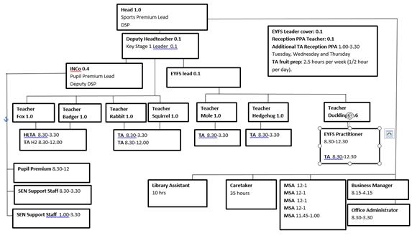

3. SUPERVISION

The jobholder is managed by a HLTA. The school's performance management policies and practice determine the frequency of meetings.

No supervision of staff.

4. JOB CONTEXT

This job is one of a set of teaching assistant jobs whose evaluated pay grade is determined by the level of responsibilities. The lowest pay grade is at Level H2, the highest at Level H4.

A jobholder need not be required to fulfil all of the duties identified in the job description. But, in order to justify the pay grade for any job above Level A, the jobholder must be spending at least 50% of his/her time on higher level duties. These duties are specified in each job description above Level A.

The set of job descriptions allows some employees to grow into the next job description provided:

- the school has sufficient work of the right level that would justify the next job description, and
b) the jobholder has gained sufficient knowledge and skill, either through qualification or through experience, to fulfil the duties of the next job description.

5. CONTACTS

The jobholder works with teachers and pupils and has occasional contact with parents and carers.

6. KNOWLEDGE, EXPERIENCE AND TRAINING

- Experience of working with or caring for children of the relevant age
- Good numeracy and literacy skills
- Basic knowledge of first-aid
- Ability to use ICT to support learning
- Understanding of learning programmes and strategies or the ability to learn quickly
- Ability to work in a team

7. PHYSICAL EFFORT
To what extent does the job involve physical effort/strain over and above what would normally be incurred in a day-to-day office environment?

The job may involve lifting children after falls or accidents

8. WORKING ENVIRONMENT
To what extent is the job exposed to objectionable, uncomfortable or noxious conditions over and above what would normally be experienced in a day-to-day office environment.

The job may include clearing up blood or other bodily fluids of children after accident of sudden illness.

Please tick to confirm this questionnaire has been agreed by the department and any job holder(s)

