Person SpecificationTeaching Assistant
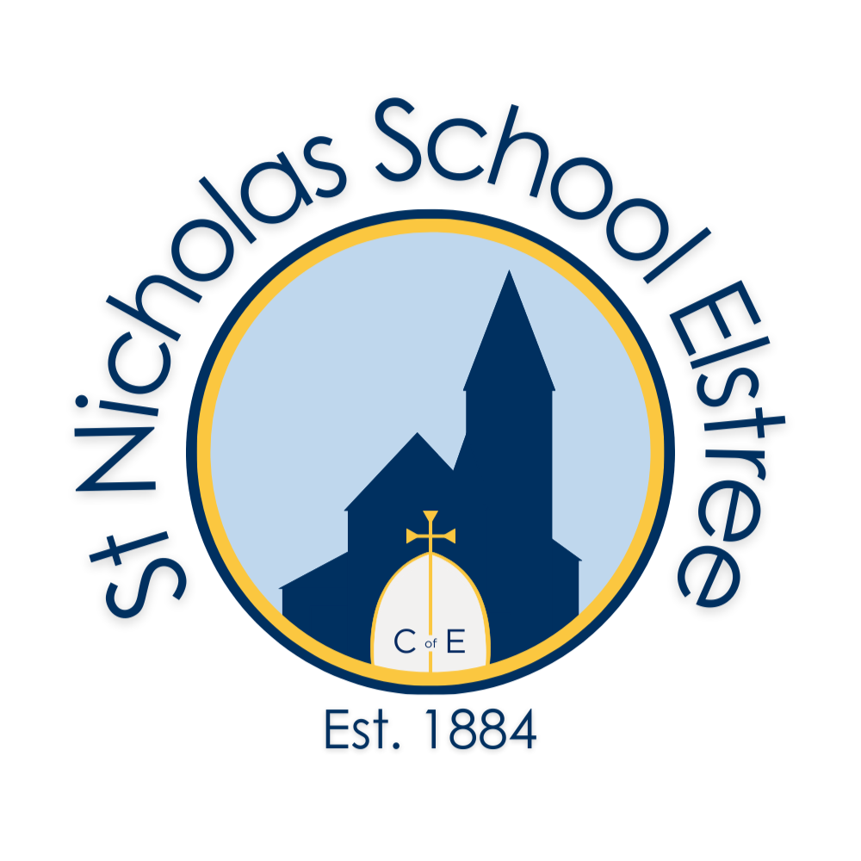 | Essential | Desirable
Qualifications & training | Level 2 or above  GCSE or equivalent English and Maths grade 4/C and above | Recognised appropriate  qualifications
Knowledge and Experience | ∙ Experience of working successfully and co-operating as a member of a team  ∙ Experience of working in an environment of working with children (either in a paid or unpaid capacity | ∙Knowledge of the primary curriculum  ∙Knowledge of Essential Letter and Sounds phonics programme and ability to deliver teaching of phonics  ∙Sound knowledge of the roles and responsibilities of a TA (if experienced)  ∙First aid experience
Skills | ∙ Good communication.  ∙ Ability to inspire children.  ∙ Excellent behaviour management strategies.  ∙ Ability to embrace new initiatives. | ∙Experience of working with children with SEN and SEMH needs  ∙ Up to date safeguarding qualification  ∙ICT literate
Personal  characteristics | ∙ Effective time management  ∙ Approachable and empathetic  ∙ Organised and resourceful  ∙ Committed  ∙ Reliable  ∙ Resilient  ∙ Good role model  ∙ Good sense of humour  ∙ High expectations for all pupils  ∙ Reflective practitioner  ∙ Promote equality and challenge prejudice

This school and the Local Authority are committed to safeguarding and promoting the welfare of children and young people and expect all staff and volunteers to share this commitment. An enhanced DBS Certificate is required for this post prior to commencement.

