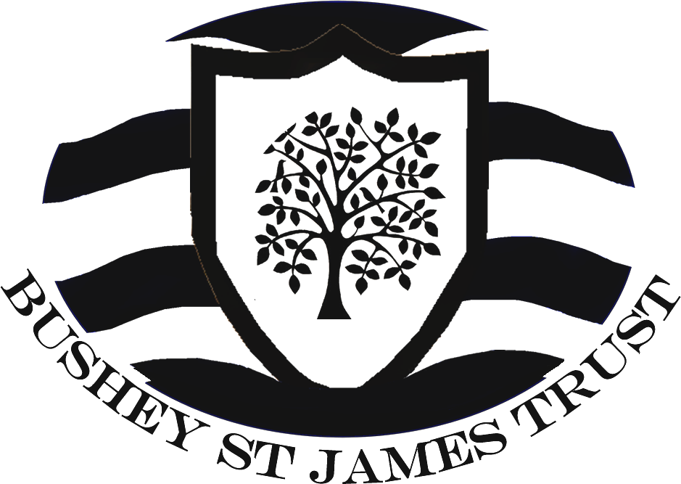
Bushey Meads School
Job Description – IT Technician

Post Title | IT Technician
Purpose | - To provide a high standard of technical support for IT equipment to all students, staff and stakeholders across the trust.  - To be invested in supporting and advising students and staff with the use of IT in order to aid teaching and learning.  - To install, configure, maintain and administer IT equipment and systems for safe, effective use, ensuring users are able to fully utilise all available equipment and resources.  - To provide knowledge and expertise in regards to IT Equipment and to procure suitable equipment to effectively support the needs and requirements of the trust.  - To be committed to the safeguarding and welfare of children, support teaching and learning and support the overall vision and values of the Trust.
Reporting to | IT Manager
Liaising with | Governors, Executive Principal, Senior Leadership Team, Teaching and Support Staff, LA representatives, external agencies and suppliers, students and parents.
Working Time | 37 hours per week, 52 Weeks
Salary/Grade | APT & C points 6 - 9 + Fringe allowance, (£23,893pa - £25,119pa + £988pa) dependent on skills and experience
Disclosure Barring Service | Enhanced with Barred List Check
MAIN (CORE) DUTIES | - To provide IT expertise and technical support to students, staff and other stakeholders within the trust.  - To maintain and develop the school’s IT provision.  - Provide first and second line fault finding, diagnosis and repair to support IT users. Make effective use of the school’s IT helpdesk system to respond to support requests, and to maintain records of diagnosis and resolution. Identify where support requests should be escalated internally, or to a third party to achieve resolution.  - Assist with the installation, appropriate configuration and maintenance of IT equipment, infrastructure and software in accordance with relevant regulations, copyright and legal requirements. Change shall be documented and follow a set configuration procedure where available. Work carried out shall comply with health and safety requirements.  - Monitor the school’s systems to ensure they are secure and available, and use is in accordance with the respective school’s IT acceptable usage policy.  - Maintain an awareness of developments in the IT industry and actively seek to develop and broaden knowledge and skills relevant to the post.  - Ensure stock of consumables and parts are monitored and replenished as necessary
Strategy | - Support the IT Manager with IT projects and installations, making recommendations  - Support the changing requirements and assisting with the development of IT across the trust.
Operational, Strategic Planning: | - Provide first and second line fault finding, diagnosis and repair services to support IT users.  - To be proactive in resolving support queries, utilising remote software and resolving issues over the telephone where possible.  - Make effective use of the school’s IT helpdesk system to respond to support requests, and to maintain records of diagnosis and resolution. Identify where support requests should be escalated internally, or to a third party to achieve resolution.  - To oversee the effective maintenance of all IT equipment, ensuring that equipment is maintained is in good working order fully complies with health & safety requirements  - Monitor the school’s systems to ensure they are secure and available, and use is in accordance with the respective school’s IT acceptable usage policy.  - Assist with the installation, appropriate configuration and maintenance of IT equipment, infrastructure and software in accordance with relevant regulations, copyright and legal requirements. Change shall be documented and follow a set configuration procedure where available. Work carried out shall comply with health and safety requirements.  - Maintain an awareness of developments in the IT industry and actively seek to develop and broaden knowledge and skills relevant to the post.
Curriculum Provision and Development: | - Keep up to date with the latest technological advances, and to implement technology which supports the needs of the trust and supports delivery of teaching across the curriculum.
Staffing, Staff Development, Recruitment and Deployment of Staff: | - To take part in the school’s staff development programme by participating in arrangements for further training and professional development.  - To assist with staff development and training as and when required or under the direction of the IT Manager.  - To work as a member of a designated team and to contribute positively to effective working relations within the school.  - To engage actively in the Performance Appraisal Review process
Quality Assurance: | - To adhere to and to help to implement school quality procedures  - To contribute to the process of monitoring and evaluation of the use of IT in line with school procedures  - To implement modifications and improvement where required  - Monitor external contracts to ensure service providers meet or exceed their obligations
Management Information: | - To maintain appropriate records and to provide relevant accurate and up-to-date information for the school’s management information system  - Ensure the trust’s data is adequately protected and that systems are used in accordance applicable school policies and legal requirements  - Ensure systems are secure and documented  - Review, develop and contribute to the implementation of the Trust’s e-safety, Data Security and other IT related policies
Communication: | - To communicate effectively with all stakeholders as required  - Where appropriate, communicate and cooperate with persons or bodies outside the school  - To follow agreed policies for communications in the school  - Attend meetings as required
Marketing and Liaison: | - To support the Trust websites and e-learning platforms  - To maintain a professional attitude when representing the trust, in particular when dealing with parents/carers, trustees, governors, external organisations, third party suppliers and any other organisations.
Management of Resources: | - Ensure stock of consumables and parts are monitored and replenished as necessary.
Other Specific Duties:
- to play a full part in the life of the school community, to support its Strategic Commitment, Purpose and Intent and to encourage staff and students to follow this example
- to promote actively the school’s policies
- to continue personal, professional development
- to actively engage in the school’s self-review and evaluation processes
- to actively engage in the school’s Appraisal of Performance processes
- to comply with the school’s Health and Safety Policy and undertake risk assessments as appropriate
- to attend meetings as determined in the meetings policy and as directed by the Executive Principal
- to comply with the school’s procedures concerning safeguarding and to ensure that training is accessed
Whilst every effort has been made to explain the main duties and responsibilities of the post, each individual task undertaken may not be identified. Employees will be expected to comply with any reasonable request from a manager to undertake work of a similar level that is not specified in this job description. Employees are expected to maintain a standard of dress conducive to their position as professionals and in setting an example to students.
All support staff may be required, from time to time, to work as directed by the Executive Principal to provide cover for administrative functions within the school. This may include exam invigilation, student supervision and other duties not normally detailed elsewhere within their job description.

June 2024

