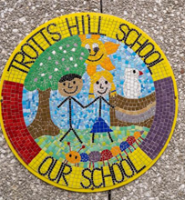

Trotts Hill School is committed to creating a diverse workforce. We will consider all qualified applicants for employment without regard to sex, race, religion, belief, sexual orientation, gender reassignment, pregnancy, maternity, age, disability, marriage or civil partnership.

Job Description Cleaner

1. Purpose of the Job

To maintain cleanliness in the designated areas in the school.

2. Main Areas of Responsibility

a) To clean the designated areas as directed by the Site Manager

b) To ensure that toilets and sinks are especially clean

c) To undertake tidying up activities if necessary before beginning to clean

d) To contribute to a working environment which supports equal opportunities and

anti-discriminatory practice

3. Supervision

Day to day supervision from the caretaker

5. Job Context

To undertake cleaning duties.

6. Contacts

Regular contact with staff and pupils sometimes with others who are visiting the

school.

7. Knowledge, Experience and Training

Understanding of hygiene and safe working practices in. Knowledge of COSHH

Understanding of safe moving and handling techniques

8. Problems and Decisions

Report broken equipment to the caretaker. Report health and safety issues such as dangerous carpet or flooring to the caretaker.

9. Physical Effort

Continuous movement throughout the shift, moving furniture, pushing the hoover, work at low and high levels.

11. Working Environment

Exposure to cleaning chemicals (follow COSHH advice).

12. ADDITIONAL INFORMATION

It is not always possible to define completely the duties and responsibilities attached to posts and some variations may be necessary from time to time.