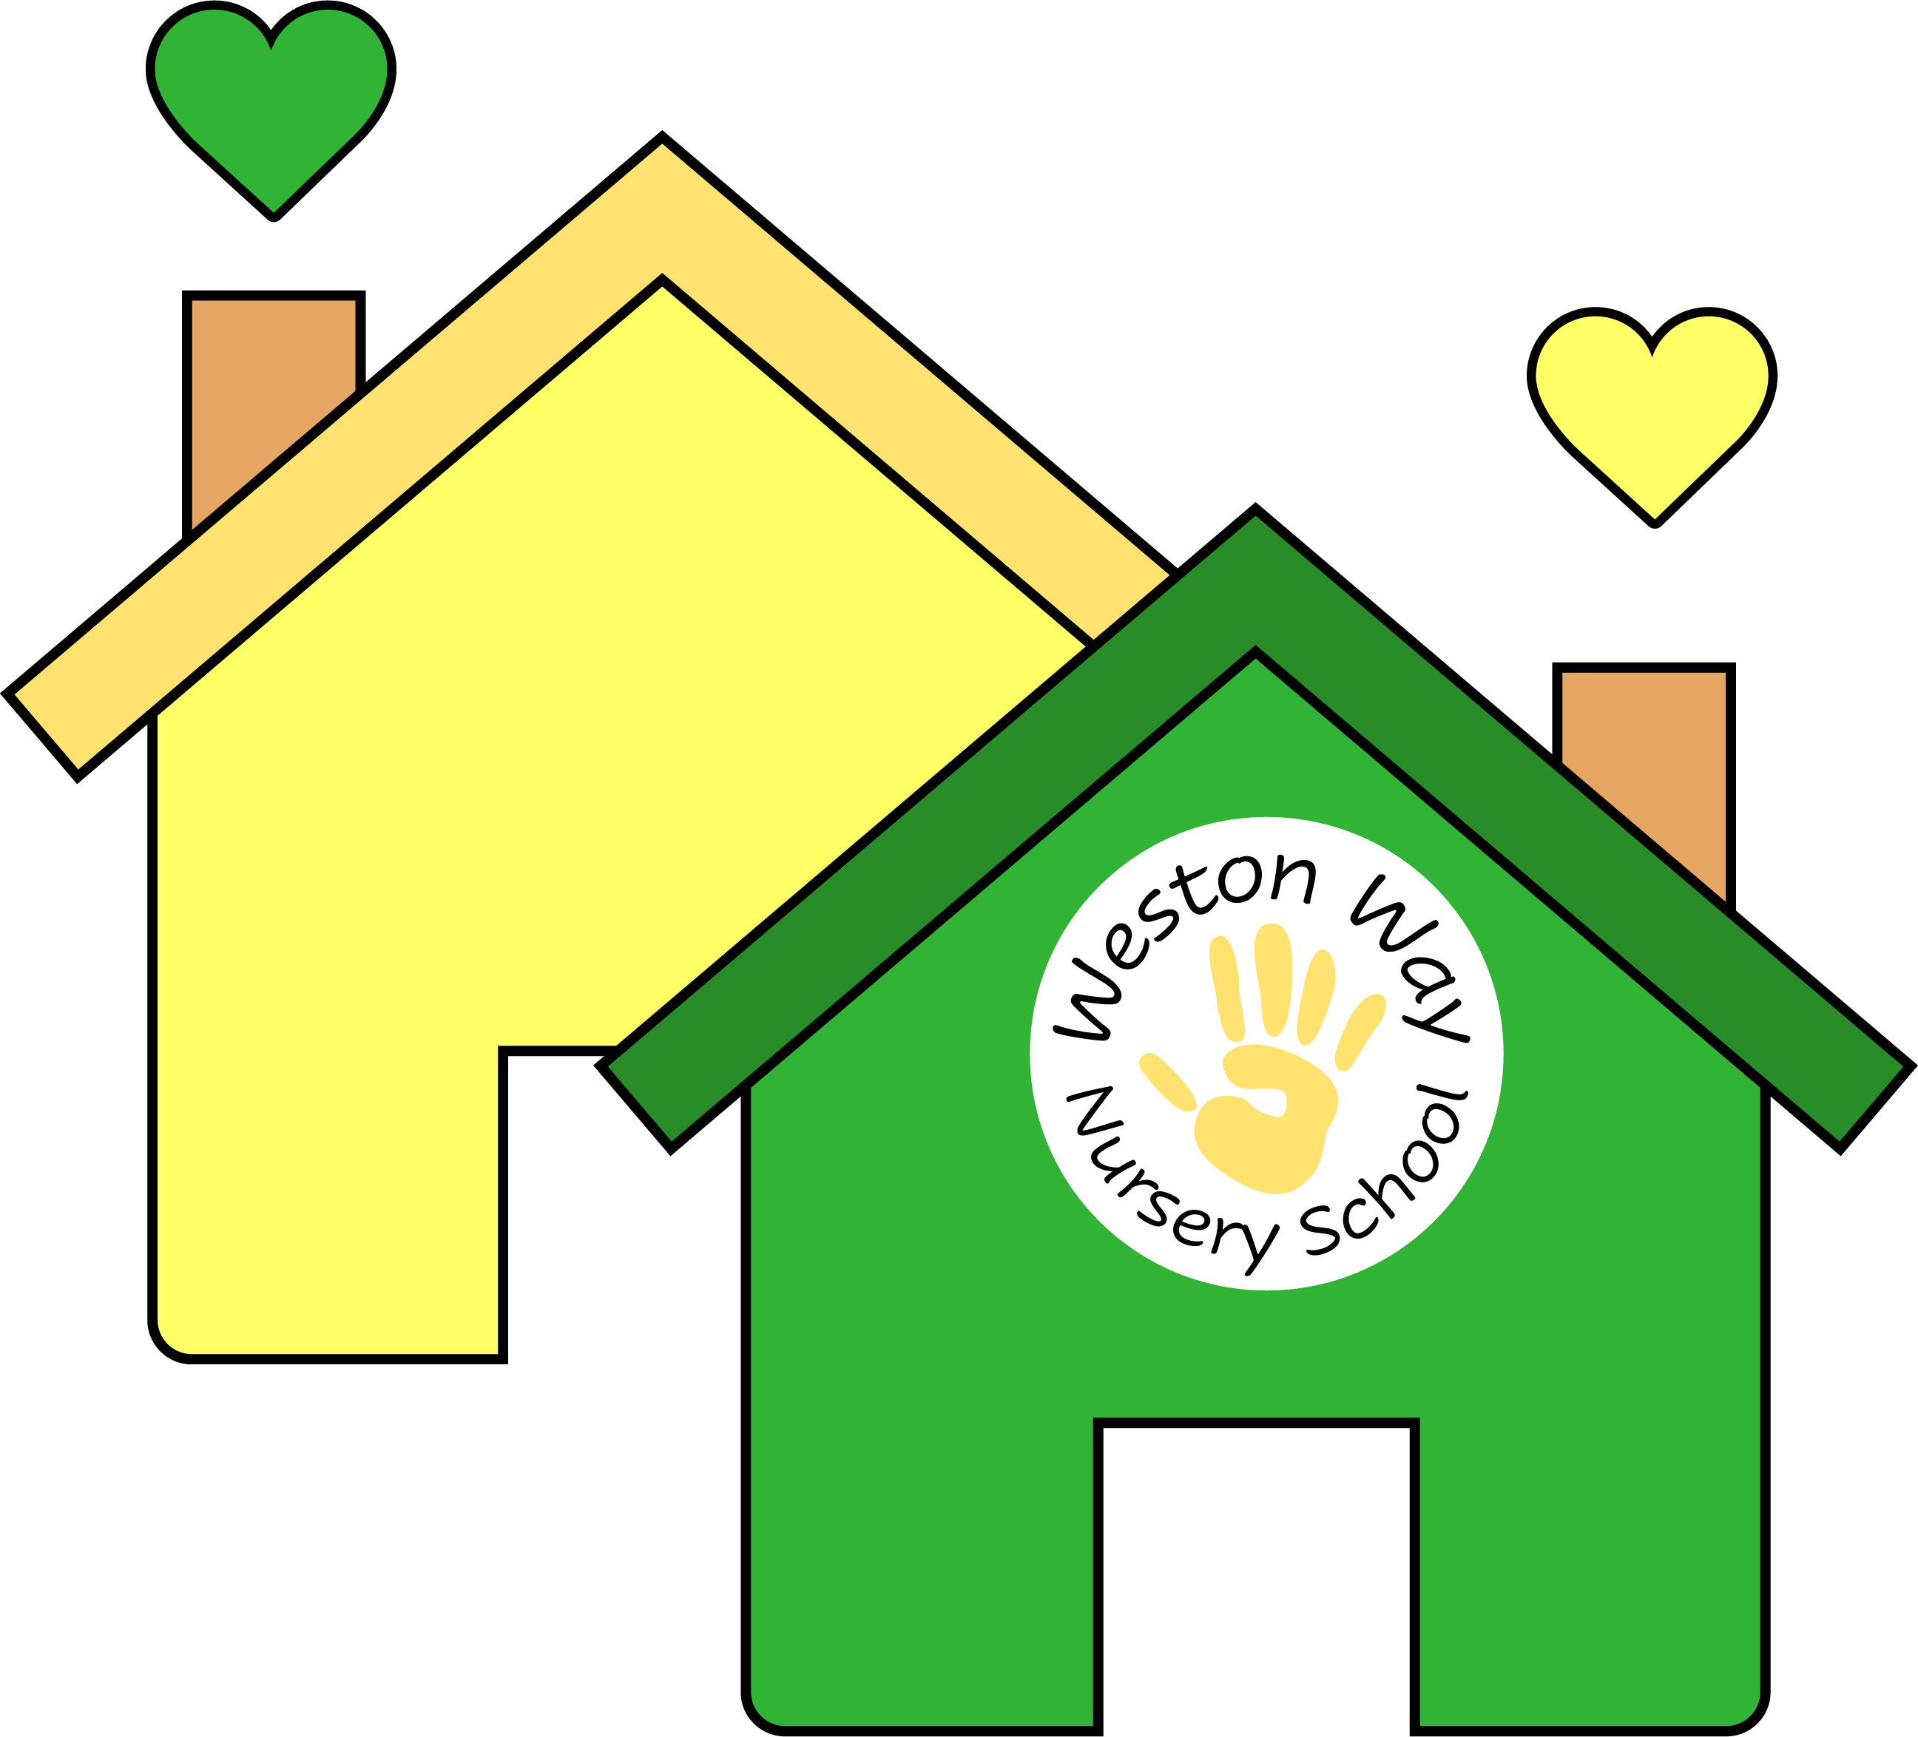
Weston Way Nursery School
Person Specification: Early Years Practitioner
 | Essential | Desirable
Experience | - Experience of working with children in a preschool/nursery/school setting  - Relevant qualifications (e.g. NVQ Level 3 in Early Years/HLTA Status/Teaching degree)  - Training or expertise in a relevant curriculum or other learning area (e.g. Early Years Foundation Stage Framework) | - Working with pupils with a range of special educational needs  - Maths and Literacy GSCE [A-C]
Skills and Attributes | - Know how to use a range of teaching and learning strategies to support children’s progress  - Plan effective activities for pupils  - Use behaviour management strategies in line with policy  - Respond to young children’s needs  - Understands the importance of the unique child within a holistic approach  - Work independently  - Able to work effectively as part of a team  - Remain calm under pressure and be able to adapt to change quickly  - Show genuine care and respect for young children and their families and a commitment to working with them  - Have empathy with those facing barriers to their learning  - Contribute to a purposeful learning environment  - Encourage children to interact and learn cooperatively with others  - Respond to guidance and proactively seek CPD opportunities  - Be a positive role model  - Ability to recognise the importance of confidentiality at all times  - Use ICT effectively  - Record basic children’s data | - Support children’s learning through play  - Assist with escorting children on educational visits
Knowledge | - Understanding of relevant codes of practice/ and legislation  - Understanding of child development and learning  - Training in relevant learning strategies  - Early Years Framework | - Working within a creative curriculum  - Knowledge of health, safety and hygiene practices and requirements  - Attends staff training sessions where appropriate
Safeguarding | - Has up-to-date knowledge of relevant legislation and guidance in relation to working with, and the protection of, children and young people  - Displays commitment to the protection and safeguarding of children and young people. | - Possession of a current Basic First Aid certificate  - Possession of a current Paediatric First Aid certificate  - Possession of Level 1 Safeguarding certificate  - Willingness to undertake training for these qualifications

