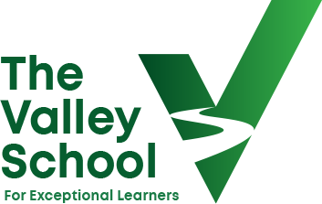

TITLE OF JOB : EYFS Teacher
Pay Range M1 to UPS 3
(Pay range and areas of responsibility will be determined by strengths, interests and experience of the successful candidate)

As of September 2025, we have a rare EYFS teaching opportunity become available at our very successful, school. The Valley school is seeking to appoint a highly effective teacher to join us; the successful candidate will play an important part in achieving our aspirations of not just being ‘Outstanding’ in most areas, but in all areas.

We are currently seeking an enthusiastic and motivated Early Years Teacher to join our teacher network and work in a dynamic and supportive team. The successful teacher will be responsible for delivering lessons and ensuring the smooth running of the classroom.
Key Responsibilities:
Plan, deliver, and assess creative and engaging lessons aligned with the EYFS curriculum, fostering a love for learning and promoting academic progress.
Create a nurturing and inclusive classroom environment where every child feels valued, respected, and supported in their learning journey.
Differentiate instruction to meet the diverse needs of students, providing additional support or challenge as required to ensure all learners reach their full potential.
Collaborate with colleagues, parents, and external stakeholders to support the holistic development of students, including attending parent-teacher meetings and contributing to school events.
Implement effective behaviour management strategies and promote positive social and emotional development among students.
Requirements:
Qualified Teacher Status (QTS) or equivalent, with experience teaching EYFS students.
Thorough understanding of the EYFS curriculum and the ability to plan and deliver engaging lessons that inspire curiosity and promote academic achievement.
Excellent communication and interpersonal skills, with the ability to build positive relationships with students, colleagues, parents, and the wider community.
A nurturing and child-cantered approach to teaching, with a passion for supporting the social, emotional, and academic development of young learners.
Flexibility, adaptability, and a positive attitude towards working collaboratively in a dynamic school environment.
Enhanced DBS clearance
Competitive salary based on experience and qualifications.
Collaborative and inclusive school community dedicated to promoting the well-being and success of all students.
Opportunity to make a meaningful impact in the lives of children and families.
We are committed to safeguarding and promoting the welfare of children and young people and expects all staff to share this commitment. All posts are subject to an enhanced DBS check and referencing.

