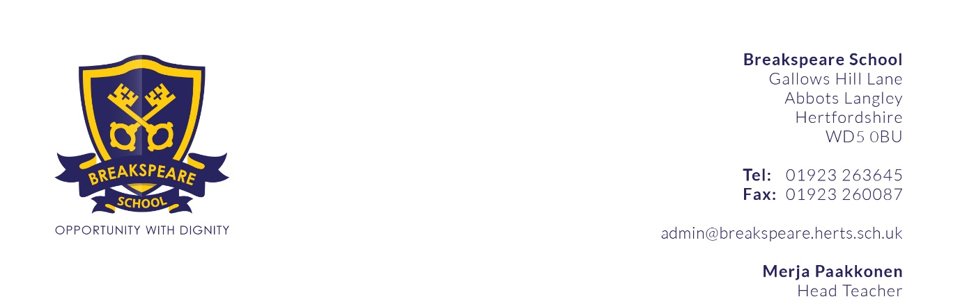
Personal Specification

POST: Site Manager Assistant
PROFILE | ESSENTIAL | DESIRABLE
Qualifications | - Driving licence  - Literate and numerate | - D1 Driving Licence/Mini-bus Driver  - Trade based qualification  - First Aid
Knowledge and Experience |  | - Experience of working within an educational environment  - Knowledge of efficient cleaning methods and materials  - Experience of driving minibuses
Abilities and Skills | - Ability to communicate effectively with children, parents, staff, governors and visitors to the school  - Ability to work both under direction and using own initiative, as appropriate  - Skills needed to undertake simple repair and maintenance tasks  - Ability to work effectively within a team  - Flexible approach to work and willingness to adapt hours of work to meet the needs of the School. | - Evidence of success in completing handyperson or DIY tasks (paid or unpaid)  - Ability to communicate and liaise effectively with persons at all levels  - Ability to prioritise and organise own tasks with minimum supervision and to work to agreed targets  - Working with SEN students  - Hold a full driving licence with D1 category
Personal Qualities | - Commitment to safeguarding young people and appropriate CRB record.  - Flexibility and sensitivity to the needs of a wide range of users of the school  - Willingness to be involved in all aspects of school life  - Reliability  - Friendly, open and approachable  - Energy to cope with a physically and emotionally challenging job  - A commitment to inclusion and equality of educational opportunity for all children, irrespective of gender, ability and ethnic origin. | - Desire and willingness to learn new skills and respond positively to advice and guidance
Breakspeare School is committed to safeguarding and promoting the welfare of children through our Child Protection Policy and expects all staff to share this commitment. The successful candidate will need to undertake an enhanced DBS check.

