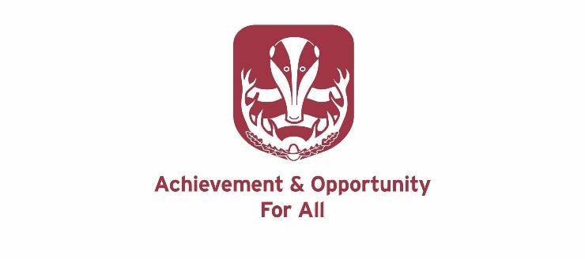

**THE RELIGIOUS EDUCATION, PHILOSOPHY AND ETHICS DEPARTMENT**

The RE, Philosophy and Ethics Department consists of four specialists. All colleagues teach across the age and ability range. The department consistently produces excellent examination results at all levels. The department has had a clear focus on developing a curriculum which is question and concept led and which ensures a balance between ‘learning about’ and ‘learning from’ religion. The department continues to develop a wide range of teaching and learning activities to ensure an experience of RE which is engaging and challenging and, when appropriate, fun.

The subject has a very high profile within the school and is valued by pupils and other staff. It is a very popular subject at all levels and exam results are some of the best within the school.

This is an excellent department with a highly committed staff. The department prides itself in the enthusiasm and excellent subject knowledge of staff, coupled with exceptionally positive relationships between staff and pupils.

**Accommodation and Resources**

The department has two specialist rooms and shares an office as part of the Humanities faculty. The department is very well resourced. All classrooms are equipped with an interactive whiteboard, all students use Chromebooks and we use Google classroom to share resources.

**Key Stage 3**

At Key Stage 3 pupils receive two hours over a two-week timetable. Pupils follow a scheme of work based on the Hertfordshire Agreed Syllabus and are all very familiar with the 8 level marking Scale.

|  |  |
| --- | --- |
| Year 7 | * Looking for God * Judaism and Sikhism: Rights & Responsibilities * Hinduism: Beliefs into Action |
| Year 8 | * Religion and Science * Why is there evil and suffering in the world? * Islamophobia and the British media |
| Year 9 | * Ethical issues in the modern world * What do we mean by right and wrong? * Is there life after death? |

Pupils visit a number of faith communities as part of their studies and the department has also welcomed visitors into school.

**Key Stage 4**

There are currently 4 classes following the Eduqas GCSE Religious Studies. The Year 11 cohort are completing Philosophy, Christianity and Hinduism. With the Year 10 cohort completing Philosophy, Christianity and Islam. There is a core RE programme which is delivered through a number of PSHCE days throughout Years 10 and 11. In 2024 the GCSE 9-7 grade was 45.5%.

**Key Stage 5**

There are 31 students following the Eduqas Religious Studies A-Level (Philosophy of Religion, Religious Ethics and Hinduism) in Years 12 and 13. In 2024 the A-C pass rate at A Level was 89.5%. Each year, several students continue pursue courses in Theology, Religious Studies or Philosophy at University.

**Induction and Support**

The school offers a full and effective induction and support programme to new and experienced teachers.

**Letter of Application**

In their letter of application, which should not exceed two sides of A4, candidates should, amongst other points, describe their approach to the teaching of RE, Philosophy and Ethics.