
The Ryde School
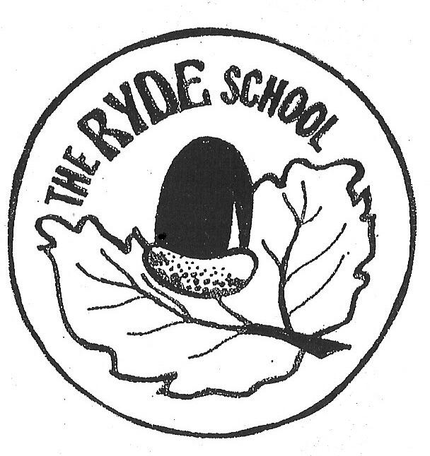
Class Teacher
Personal Specification

Qualifications

- Qualified teacher status.

Experience

- The teacher we employ must have experience of teaching in Key Stage 2.

Skills and Abilities

- Display commitment to the protection and safeguarding of children and young people.
- Be able to treat all pupils, staff, parents and carers, governors and school visitors with respect.
- Able to maintain good relationships with pupils, parents, staff and governors.
- Ability to inspire, lead and motivate pupils.
- Demonstrate consistently good or outstanding classroom practice
- Be able to promote a positive ethos and be a good role model.
- Ability to create a stimulating learning environment.
- Have strong positive behaviour management skills.
- Good organisation and time management skills.
- Maintain high standards of honesty and integrity in all aspects of work.

Knowledge

- Up to date knowledge of relevant legislation and guidance in relation to working with, and protection of, children and young people.
- Knowledge of the primary curriculum.
- Knowledge of and commitment to inclusive practice and equal opportunities.
- Understanding of children with special educational needs and the needs of the more-able child.

