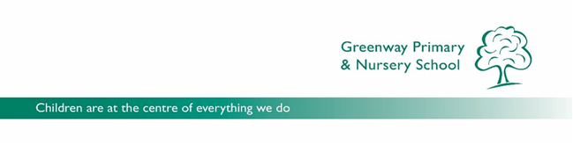

|  |  |  |  |  |
| --- | --- | --- | --- | --- |
|  |  | **Essential** | **Desirable** | **Method of assessment** |
| **Qualifications** | * Qualified teacher status (QTS) * Evidence of professional development | **√**  **√** |  | Application form, certificates |
| **Experience** | * Experience of teaching reception * Experience of teaching across the primary phase * Effective involvement with parents * Experience of developing practice * Lead a curriculum area across the school | **√**  **√** | **√**  **√**  **√** | Application form and references |
| **Knowledge and understanding** | * Knowledge of what constitutes quality and high standards in learning and teaching * Commitment to school vision, policies and initiatives * Strategies for engaging all learners * Achieving high standards * Good grasp of current educational issues * How to plan, organise and prioritise * Knowledge of safeguarding and child protection procedures | **√**  **√**  **√**  **√**  **√**  **√**  **√** |  | Application form, references and interview |
| **Skills and Abilities** | * Excellent classroom practice * High expectations * Good behaviour management skills * Ability to inspire and motivate children * To have a ‘can do’ attitude * Good communication skills at all levels * Confident with ICT * Able to reflect on own practice and identify areas of improvement | **√**  **√**  **√**  **√**  **√**  **√**  **√**  **√** |  | Application form, references and interview |
| **Personal Qualities** | * Commitment * Enthusiasm * Positive outlook * Sense of humour * Desire to become fully involved in school life * Flexible | **√**  **√**  **√**  **√**  **√** | **√** | Application form, references and interview |

**GREENWAY PRIMARY AND NURSERY SCHOOL**

**PERSON SPECIFICATION**

**Early Years Teacher**

In providing a supporting statement for their application candidates should try to include

as much evidence as possible based on the following person specification: