**Presdales School**



**Exam Invigilators**

**£24027 + fringe (FTE)**

We are looking to recruit Exam Invigilators to join our existing team, to supervise students taking exams. You will be required on an ad hoc basis throughout the academic year. However, you must be available in May and June for the public exams.

No experience is necessary as full training will be given, but applicants will need to have competent IT skills and a good understanding of young people. Sound communication and organisation skills are essential, along with attention to detail and the ability to maintain confidentiality.

Full details and an application form can be found on the school website.

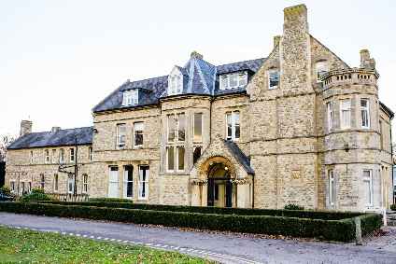Presdales School is a girls’ single sex comprehensive school in Ware for girls aged 11-18, with boys welcomed in the Sixth Form. We are a school which values all students, irrespective of their age and ability and helps them to exceed expectations through high quality teaching and learning and the opportunity to take part in a wide variety of activities which will enrich their educational and personal development beyond the classroom.

We provide a caring environment where all students are supported, as well as challenged, to ensure that there is no limit to their potential. We prepare our students for a world that is constantly changing by encouraging them to be independent learners who are determined, confident and who never give up. Alongside academic excellence there is a strong focus on enjoyment, excellent behaviour and respect for all.

*The school is committed to safeguarding and promoting the welfare of young people and expect staff to share this commitment. All posts are subject to a safer recruitment process which includes enhanced criminal records and barring checks, scrutiny of employment history, referencing and other vetting checks, including online searches.*

**Closing date for applications: 9.00 am, Monday 10th February 2025**

Please submit, as soon as possible:

1. A letter of application
2. A completed application form (available on the school website)

*Presdales School is committed to ensuring inclusion, diversity and equality of opportunity. We welcome applications from all suitable candidates and encourage those from underrepresented groups, and/or with protected characteristics, to apply.*

You can post your application to the school, or send by email to [recruitment](mailto:recruitment)@presdales.herts.sch.uk

Please note that CVs will not be accepted