Moss Bury Primary School and Nursery
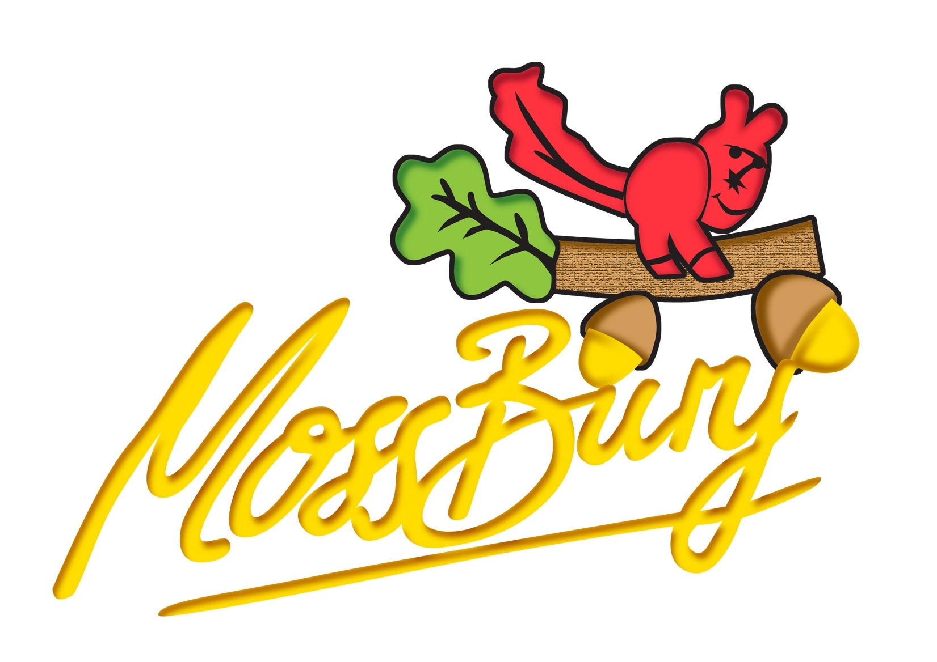
Webb Rise
Stevenage
Hertfordshire
SG1 5PA
Tel: 01438 222 300
Fax: 01438 222 301
e-Mail :admin@mossbury.herts.sch.uk

Headteacher: Callum Newbury

TITLE OF JOB : MIDDAY SUPERVISORY ASSISTANT
LOCATION : SCHOOLS
GRADE : HB

- PURPOSE OF YOUR JOB

To prepare the dining room for school lunches and clear away afterwards and to supervise pupils whilst they eat.

To supervise pupils on the playground / in classes (indoor play) and to assist with First Aid.

- MAIN AREAS OF RESPONSIBILITY

Prepare the layout of the tables in preparation for lunch including laying up tables.

Supervise the pupils when they are in the dining room eating lunch.

Clear up the dining room after the lunch break including clearing any food and wrapping left on the tables, wiping the tables and sweeping the floor.

- ORGANISATION CHART

Senior Supervisory Assistant

Supervisory Assistant

Midday Supervisory Assistant

- SUPERVISION

Supervised on a daily basis either by the Supervisory Assistant or Senior Supervisory Assistant.

- JOB CONTEXT
Please tick to confirm this questionnaire has been agreed by the department and any job holder(s)

Working with supervisory assistants and catering staff to ensure that the school lunch breaks start and finish on time. Ensuring that pupils have either a school meal or packed lunch and supervising the pupils over the lunch period.

- CONTACTS

Catering Staff

- KNOWLEDGE, EXPERIENCE AND TRAINING

Experience of working in an environment where there are children and young people would be desirable but not necessary.

Knowledge of basic hygiene procedures.

- PROBLEMS AND DECISIONS

Sometimes troublesome behaviour from pupils in the dining room which is reported to the Supervisory Assistant.

Occasionally, a child may feel unwell during lunch and need help and this is also reported to the Supervisory Assistant if necessary.

A pupil may fall or hurt themselves – First Aid should be administered and reported in the Accident Book. Accident forms should be completed where necessary – a copy should go home with the pupil and a copy should be sent to the school office.

- PHYSICAL EFFORT

Moving and carrying dining tables and chairs at the beginning and end of the shift.

- WORKING ENVIRONMENT

This work is done indoors and there are not really hazardous conditions.

- ADDITIONAL INFORMATION

Pupils can sometimes display threatening behaviour.

It is not always possible to define completely the duties and responsibilities attached to posts and some variations may be necessary from time to time.

T

