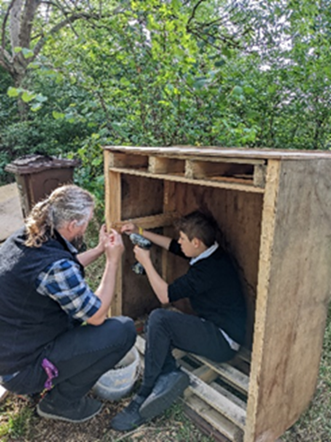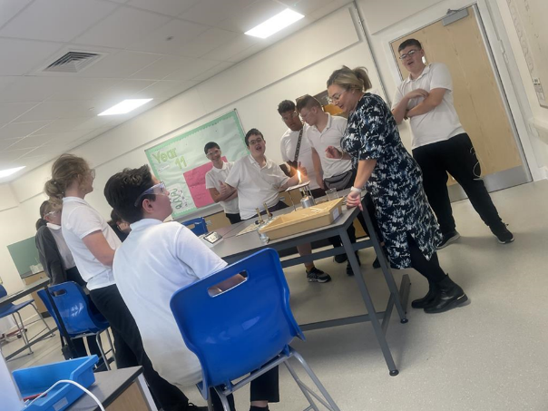



**The Valley School**

**Application Pack: Deputy Headteacher**

Dear Candidate,

A warm welcome and thank you for taking the time to express your interest in the role of Deputy Headteacher at The Valley School.

The Valley School is a popular and heavily oversubscribed secondary school for students with learning difficulties. Our mission statement, "To be a warm and caring centre of excellence, providing a safe and supportive environment for secondary school children with learning needs”, represents the education that students will receive and the community they will be immersed in at The Valley School.

We believe that education is an empowering force, that it possesses the capacity to equip the students with the knowledge and skills that future proof them for their life ahead.

We want to ensure their education opens doors, offers positive experiences and encourages the students to think big about their life ahead.

This is an exciting time to join our school and make your impression as we continue to build and grow on our successes. The school was rated ‘Outstanding’ for Behaviour and Personal Development and ‘Good in all other areas by Ofsted in November 2024 and we are focused on continuous improvement with the aspiration to be rated ‘Outstanding’ in all areas by our next inspection.

If you want to provide outstanding learning opportunities for students within a forward-thinking, hardworking school community, we would like to hear from you.

The information included in this pack will give you an insight into our school; the high aspirations we have for our students and the excellent support and opportunities given to The Valley staff.

Please view the school website.

We welcome pre booked visits from prospective candidates prior to any application; please see contact details at the end of this pack about arranging

Yours sincerely

*Liz Ellis*

David Pearce Headteacher Liz Ellis Chair of Governors

**The Valley School: Job Description**

|  |  |
| --- | --- |
| **Title of Post** | **Deputy Headteacher** |
| **Grade** | **Leadership Scale 16-20** |
| **Reporting To** | **Headteacher** |
| **Date** | **September 2025** |

The duties outlined in this job description reflect and develop those covered by the latest School Teachers’ Pay and Conditions Document which is available from the Headteacher or alternatively can be found online on the “DfE" - Department for Education website. This job description may be modified by the Headteacher, with your agreement, to reflect or anticipate changes which are commensurate with the salary and job title.

Expected “standards” to be reached and maintained are clearly defined within the Performance Management and Appraisal documentation and should be referred to regularly for further clarification and specific detail.

#### 1 PURPOSE OF YOUR JOB

**Leaders of The Valley School need to have the following priorities (within their areas of responsibility):**

* To lead the school to provide the very best learning environment and experiences for the students, which lead to the greatest range of life choices
* To take on significant challenges and to seek new ways to achieve the school’s objectives
* To lead with a clear and articulated vision, always showing personal and professional commitment to that vision
* To remain determined and motivated whilst under pressure
* To have a highly developed level of conceptual thinking, which leads to consolidation and innovation
* To be forward-thinking; to address immediate issues whilst looking ahead for future opportunities
* To create a team who understand and embrace the vision for the school
* To inspire and enable others to achieve aspirational objectives
* To secure strategic direction, with operational skills, towards school priorities
* To lead on and model effective teaching and learning practices
* To keep effective pedagogy at the centre of the curriculum
* To engage positively with Students, parents and the wider community
* To understand the staffing needs of the school
* To understand the local, national and international influences on learning
* To look at practice, policy and research to inform developments
* To be analytical and focused in finding solutions
* To provide opportunities and direction for staff to engage in ongoing professional development and to fulfil the requirements of their role
* To secure high levels of performance and accountability from all staff

**2. MAIN AREAS OF RESPONSIBILITY (by negotiation, some will be shared with the Headteacher and some will be sole responsibilities, as defined in the staffing structure)**

* **Deputise for the Headteacher in his absence**
* **Engage positively with stakeholders**Be actively involved with the work of the Governing Body. Ensure that parents and carers are involved and influential in the daily life of the school. Work closely with the local community, including local schools, to raise the profile of the school and to impact upon learning.
* **Policy and Practice**Work closely with the Headteacher to ensure that all policies are in place and that they reflect the values and beliefs of the school. Develop outstanding practice and ensure that it is securely embedded. Contribute significantly to the direction of the School Development Plan and completion of the School Evaluation Form, taking account of the priorities of the school. Contribute to the recruitment, selection, and appointment of staff. Take part in the school’s appraisal procedures and support the appraisal process of other staff taking in to account the priorities of the school.
* **Lead on safeguarding**

Ensure that the safeguarding culture in the school is maintained, and all systems and processes are sustainable, accurate and robust.

* **Influence Curriculum Development**

Ensure students have full access to a broad and balanced curriculum including the National Curriculum which is adapted to meet students’ learning needs and styles.

Work with subject leads to develop a curriculum designed to be challenging and appropriate to the student’s stage of development.

Monitor student progress and engagement and adapt the curriculum where necessary. Support the Assistant Headteacher in timetabling the curriculum.

* **Student Premium**

Ensure that the school’s Student premium Funding is allocated effectively to reduce the inequalities and gaps in attainment between those students who receive free school meals (or have ever received them in the last 6 years), children of Service personnel, students who are looked after (from the first day of the care episode), and their peers and report annually on the impact.

* **Support the Headteacher in leading teaching and learning**

Understand the local, national and global influences on learning and developments in the field of special education and look at current practice, policy and research to inform pedagogy and practice

Seek to provide the very best learning environment and experiences for the students including the use of current technologies, making learning creative and exciting, and leading to the greatest range of life choices for them

Lead and model effective teaching and learning practices, securing high levels of performance and accountability from all staff to overcome disadvantage and to advance equality

Create a strong value-based ethos within which staff are motivated and supported to develop their own skills and subject knowledge and to support each other, providing opportunities for staff to engage in on-going high quality professional development

Hold all staff to account for their professional conduct and practice

Engage positively with students, parents, governors and the wider community

Monitor the quality of learning.

* **Lead Attendance protocols**

Ensure that the responsibility for good attendance is shared between school, parents and students.

Work with parents to meet their legal responsibility for ensuring the students regular and punctual attendance.

Support parents where they are not meeting this responsibility and provide appropriate challenge where required.

* **SLT link (Year group or Key Stage)**Through Line-Management of the Interventions Lead, ensure that all students who need support and intervention that is additional to or different from what is offered for all students have their needs met in a planned and monitored way. Oversee respective Heads of Year to ensure that effective and productive relationships are in place between the school and families.  
  Intervene to bring about a successful outcome if families are in need of Senior Leadership involvement.
* **Support the SENCO with EHCP Reviews**

Ensure that EHC planning is of a high quality, by supporting tutors in their preparation and by overseeing the review of plans. Monitor the quality of provision, in line with the EHCPs. Ensure that ILPs reflect the needs identified in EHCPs. Ensure that the values and priorities of the school are embedded in EHC plans.

* **Outside agencies**Liaise with outside agencies as and when necessary to ensure all our students have their needs met whilst at the school and in preparation for transition.
* **ECT Induction Lead**Ensure that ECTs are supported to become effective in their future careers. Retain an up-to-date knowledge of training routes and qualification criteria, in line with national standards. Liaise with the Appropriate Body and HfL to coordinate the induction programme for ECTs. Carry out assessments and regular progress reviews of ECTs against the Teachers’ Standards. Support Mentors to carry out their role effectively.
* **Staff welfare**Respond sensitively and appropriately to staff needs. Mentor the Associate SLT member of staff.

**3. LINE MANAGEMENT/SALARY RANGES/JOB CONTEXT**

As defined in current PA appendices

**4. PHYSICAL EFFORT**

Robust practices and policies are in place to meet the needs of our students, including their emotional and behavioural needs. However, all jobs at The Valley School may require physical effort including walking, running, lifting and occasional physical intervention, for which all staff are trained.

**5. WORKING ENVIRONMENT**

The postholder may be required to work in any part of the school, internal or external.

**6. ADDITIONAL INFORMATION**

You may, from time to time, be required to attend meetings off site and to participate in provision planning and strategic development processes.

The postholder is required to contribute to and support the overall aims and ethos of the school. All staff are required to participate in training and other learning activities, and in performance management and development as required by the school’s policies and procedures

It is not always possible to define completely the duties and responsibilities attached to posts and some variations may be necessary from time to time.

**Person Specification**

The Governors are looking for an exceptional leader to play their part in driving and shaping the future of The Valley School. Our person specification is underpinned by our educational philosophy.

|  |  |  |  |  |
| --- | --- | --- | --- | --- |
| **Aspect** | **Requirement** | Application | Interview | Tasks |
| **Qualifications and Training** | Educated to degree level | x |  |  |
|  | Has qualified teacher status as defined by the DFE | x |  |  |
|  | Evidence of recent relevant professional development in preparation for Deputy Headship | x |  |  |
| **Knowledge and Experience** | Successfully, led, planned, managed and evaluated change which has had a significant impact at whole school level | x | x |  |
|  | Successfully made sustained progress with students with SEND. | x | x |  |
|  | Demonstrate the ability to work strategically and successfully at a senior leadership level | x | x |  |
|  | Experience of teaching in more than one school | x |  |  |
|  | Experience as an Assistant Headteacher or equivalent | x |  |  |
|  | Working successfully with other education partners and providers | x |  |  |
|  | Demonstrate outstanding, sustained and successful experience as a teacher | x | x |  |
|  | Can demonstrate strategic thinking and planning that builds, communicates and carries forward a coherent and shared vision | x | x | x |
|  | Experience of developing and sustaining a learning culture that has student well-being and development at its core, including high expectations and standards of progress | x | x |  |
|  | Experience of monitoring and evaluating the effectiveness of teaching and learning, including its outcomes in terms of standards and achievement and personal development and wellbeing | x | x |  |
| **Aspect** | **Requirement** | Application | Interview | Tasks |
|  | Experience of implementing strategies for improving the quality of teaching and learning, including promoting excellence and challenging poor performance | x | x |  |
|  | Know how to promote an open, fair and equitable culture | x | x |  |
|  | Understand the significance of interpersonal relationships and strategies for promoting individual and team development | x | x | x |
|  | Understand how to sustain effective organisational structures, systems, policies and procedures | x | x |  |
|  | Successful experience of the delegation of leadership responsibilities and management tasks as appropriate, and monitor their implementation | x | x |  |
|  | Experience of holding individuals, teams and whole school to account for student learning outcomes | x | x |  |
|  | Show a practical understanding of how to analyse and use the full range of evidence, including performance data and external evaluations, to support, monitor and evaluate and improve aspects of the school, including challenging poor performance | x | x | x |
|  | Demonstrate a clear understanding of the principles and practice of quality assurance systems, including school review, self - evaluation and performance management and have experience of these | x | x |  |
|  | Experience of strategies that encourage parents and carers to support their son/daughter’s learning | x | x |  |
|  | Experience of building and sustaining effective relationships with parents, carers, other schools and partners and the broader community that enhance the education of students | x | x |  |
| **Personal Skills & Attributes** | The ability to inspire, challenge, motivate and empower teams and individuals to achieve high standards | x | x |  |
|  | Demonstrate personal and professional integrity, including modelling values and vision | x | x | x |
| **Aspect** | **Requirement** | Application | Interview | Tasks |
|  | Demonstrate a capacity for sustained hard work with energy and vigour | x | x |  |
|  | Demonstrate resilience and optimism | x | x | x |
|  | The ability to prioritise, plan and organise themselves and others | x | x | x |
|  | Demonstrate personal enthusiasm and commitment to leadership aimed at making a positive difference to young people | x | x | x |
|  | Be self-critical and reflective on own practice | x | x | x |
|  | Ability to liaise with different groups to achieve a positive outcome | x | x | x |
|  | The ability to think analytically and creatively and demonstrate initiative in solving problems | x | x | x |
|  | Embed successful change across the school by effectively completing tasks and evaluating outcomes within agreed timescales | x | x |  |

**Application form**

Using the standard application form provided (CVs are not accepted) on Teach in Herts please complete all aspects of the form fully. Include your full work history with no gaps since leaving school education. Include all the professional development you have completed, particularly those in recent years which have helped to prepare you for becoming a Senior Leader.

**Personal specification and Personal Statement**

When writing your responses it is important you address the requirements in the person specification. Ensure to evidence additional aspects such as training, qualifications together with your background and experience with the person statement.

**Letter of application**

In addition to you letter of application, we would like you to describe in no more than 1000 words evidence of the impact you have had as a senior leader on educational standards and provision for SEND students over the past three years.

**References**

Please make sure your referees are aware of your application and that they can provide a swift turn around. Preferred referees are your last two employers, and you should provide their official organisational email address for us to contact. One referee is likely to be your current or most recent Headteacher or Chair of Governors.

**Safeguarding**

The Valley School is committed to safeguarding and promoting the welfare of children and young people and expects all staff and volunteers to share this commitment. Appointment to this post is subject to an enhanced Disclosure and Barring Service check, including the barred list, as well as other pre-appointment checks outlined in Keeping Children Safe in Education (2018)